**Name: Vijay Vishnu pb**

**Roll No: 49**

**Batch: B**

**Date: 04/04/2022**

**NETWORKING & SYSTEM ADMINISTRATION LAB**

**Experiment No.: 2**

**Aim**

Familiarization of the hardware components in a computer.

**Procedure**

* **SYSTEM UNIT**

A System Unit is the main component of a personal computer, which houses the other devices necessary for the computer to function. It is comprised of a chassis and the internal components of a personal computer such as the system board (mother board), the microprocessor, memory modules, disk drives, adapter cards, the power supply, a fan or other cooling device and ports for connecting external components such as monitors, keyboards, mice, and other devices.

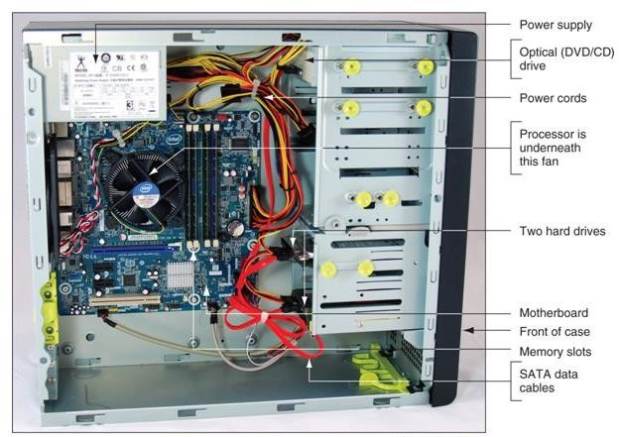

***System Unit Components***

* **DISPLAY DEVICES**

A display device is a personal computer component and is an output device that enables user to view the text and graphical data associated with a computer program. Display devices commonly connect to the system unit via a cable, and they have controls to adjust the settings for the device. They vary in size and shape, as well as the technology used.

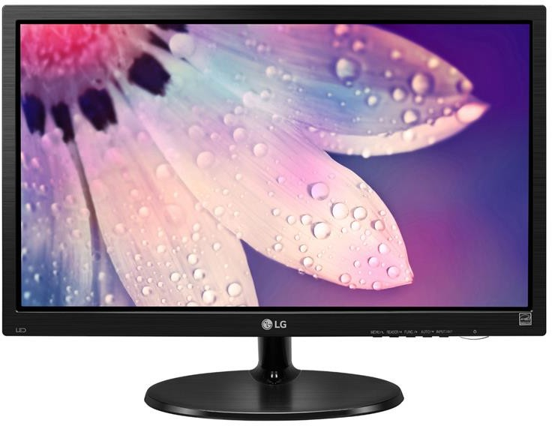

* **INPUT DEVICES**

An input device is a personal computer component that enables users to enter data or instructions into a computer. The most common input devices are keyboards and computer mice. Input devices can connect to the system via a cable or a wireless connection.

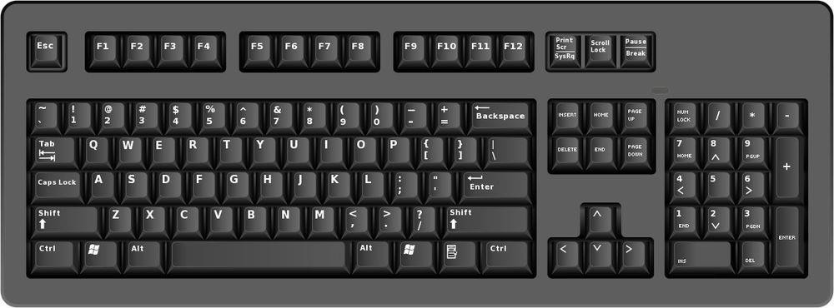

keyboard

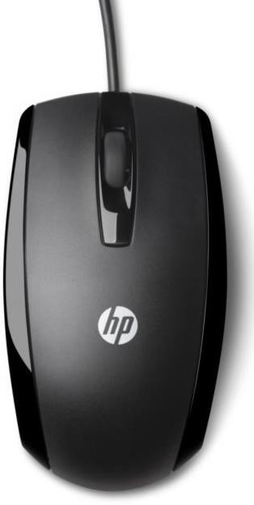

mouse

* **EXTERNAL DEVICES**

Any peripherals devices that are not housed inside the system unit are inherently external devices. A personal computer’s functionality can be enhanced by connecting different types of external devices to the system unit, often called peripherals devices. These devices typically provide alternative input or output methods or additional data storage. External devices are connected to the system unit via a cable or wireless connection. Some of them have their own power source and some draw power from the system.

|  |  |  |
| --- | --- | --- |
| **External Devices** | | **Functionality** |
|  | Microphone | Provides audio input |
|  | Digital camera | Provides graphical input |
|  | Printer | Provides printed output |
|  | Network device | Provides communication with other computers, such as access to the Internet. |
|  | External device | Provides additional data storage |

* **POWER SUPPLIES**

Computers use a power supply to convert AC power into a lower voltage DC power required by internal components.

Desktop computer power supply form factors include:

• Advanced Technology (AT) – original power supply for legacy computer systems

• AT Extended (ATX) – updated version of the AT

• ATX12V – the most common power supply on the market today

• EPS12V – originally designed for network servers but is now commonly used in high-end desktop models.

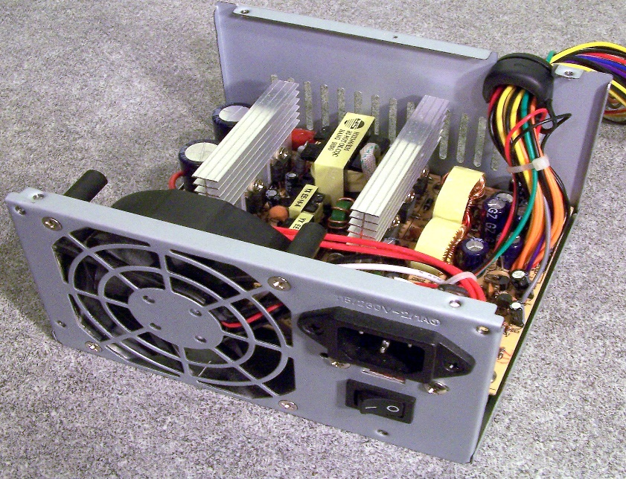

* **CONNECTORS**

A power supply includes several different connectors. They are used to power various internal components such as the motherboard and disk drives.

Some examples are:

• 20-pin or 24-pin slotted connector

• SATA keyed connector

• Molex keyed connector

• Berg keyed connector

• 4-pin to 8-pin auxiliary power connector

• 6/8-pin PCIe power connector

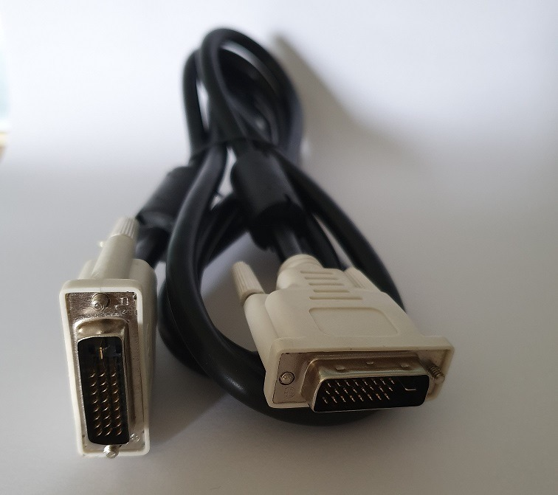

* **MOTHERBOARD**

The motherboard is the key circuit board holding the essential processing parts of a computer. It allows all the parts of your computer to receive power and communicate with one another. It is usually screwed to the case along its largest face, which could be the bottom or the side of the case depending on the form factor and orientation. The form factor describes the shape and layout of the motherboard. It affects where individual components go and the shape of the computer's case. Attached directly to the motherboard are the CPU, RAM, expansion cards, networking, video, and audio components.

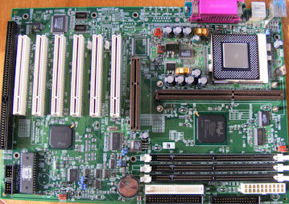

* **CHIPSET**

Chipset consists of the integrated circuits on the motherboard that control how system hardware interacts with the CPU and motherboard.

Most chipsets consist of the following two types:

• Northbridge – Controls high speed access to the RAM and video card.

• Southbridge – Allows the CPU to communicate with slower speed devices including hard drives, Universal Serial Bus (USB) ports, and expansion slots.

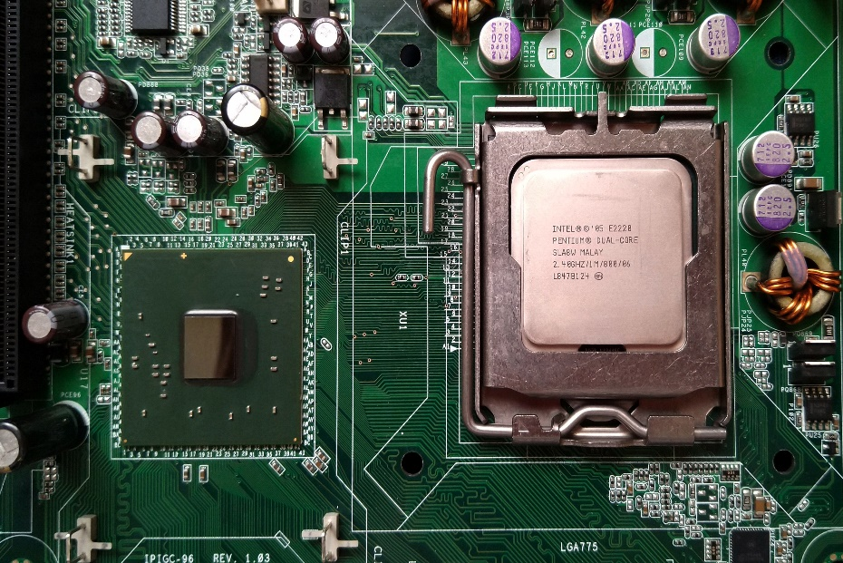

* **CPU**

The central processing unit (CPU) is responsible for interpreting and executing commands. The CPU is a small microchip that resides within a CPU package. The CPU socket is the connection between the motherboard and the processor.

Modern CPU sockets and processor packages are built in following architectures: • Pin Grid Array (PGA) - the pins are on the underside of the processor package and is inserted into the motherboard CPU socket.

• Land Grid Array (LGA) - the pins are in the socket instead of on the processor.

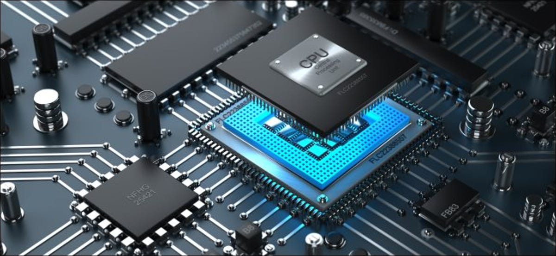

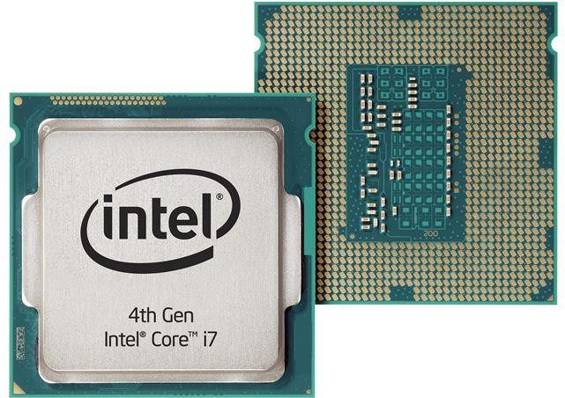

* **RAM**

Random access memory (RAM) is a series of small cards or modules plugged into slots on the motherboard. The CPU can request any data in RAM. It is then located, opened, and delivered to the CPU for processing in a few billionths of a second. Since all the contents of RAM are erased when you turn off the computer, RAM is the temporary or volatile storage location for the computer.

RAM contains multiplexing and demultiplexing circuitry, to connect the data lines to the addressed storage for reading or writing the entry. Usually more than one bit of storage is accessed by the same address, and RAM devices often have multiple data lines and are said to be "8-bit" or "16-bit", etc. devices.

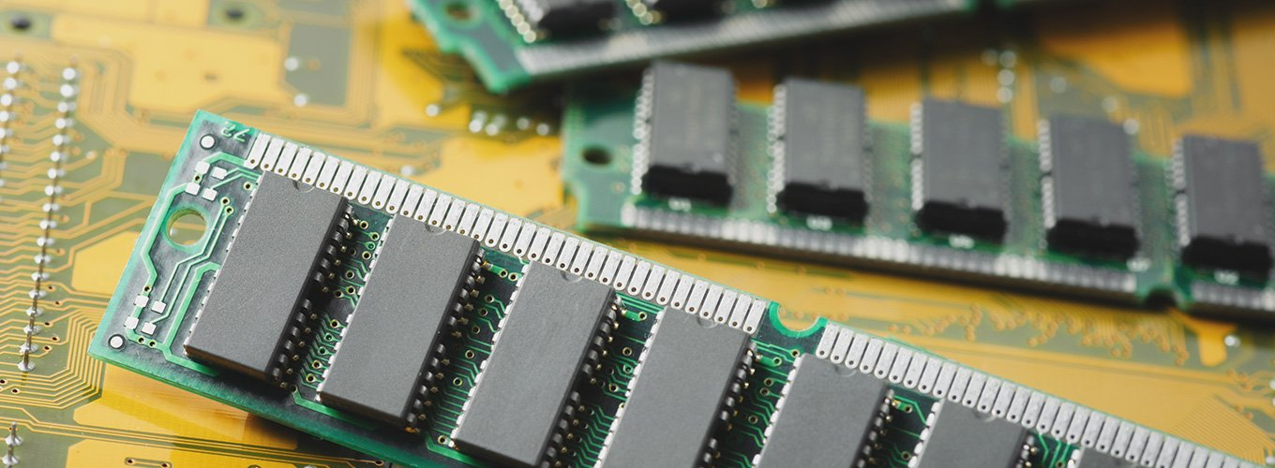

* **ROM**

Read-only memory, or ROM, is a type of computer storage containing [non-volatile](https://www.techtarget.com/searchstorage/definition/nonvolatile-memory), permanent data that, normally, can only be read, not written to. ROM contains the programming that allows a computer to start up or regenerate each time it is turned on. ROM also performs large input/output ([I/O](https://whatis.techtarget.com/definition/input-output-I-O)) tasks and protects programs or software instructions. Once data is written on a ROM chip, it cannot be removed.

Almost every computer incorporates a small amount of ROM that contains the start-up [firmware](https://whatis.techtarget.com/definition/firmware). This boot firmware is called the basic input/output system ([BIOS](https://whatis.techtarget.com/definition/BIOS-basic-input-output-system)). This software consists of code that instructs the boot-up processes for the computer -- such as loading the operating system ([OS](https://whatis.techtarget.com/definition/operating-system-OS)) into the random access memory ([RAM](https://www.techtarget.com/searchstorage/definition/RAM-random-access-memory)) or running hardware diagnostics. Consequently, ROM is most often used for firmware updates.

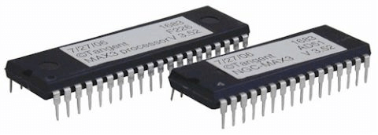

* **SEMICONDUCTOR MEMORY**

Semiconductor memory is used in any electronics assembly that uses computer processing technology. Semiconductor memory is the essential electronics component needed for any computer based PCB assembly.

In addition to this, memory cards have become commonplace items for temporarily storing data - everything from the portable flash memory cards used for transferring files, to semiconductor memory cards used in cameras, mobile phones and the like.

The use of semiconductor memory has grown, and the size of these memory cards has increased as the need for larger and larger amounts of storage is needed.

To meet the growing needs for semiconductor memory, there are many types and technologies that are used. As the demand grows new memory technologies are being introduced and the existing types and technologies are being further developed.

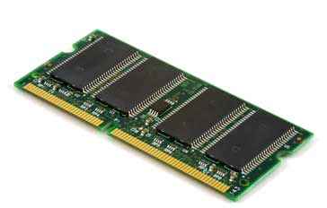

* **BUSES**

A bus is a set of wires through which data can be sent to the different parts of the computer system. Buses connect the major computer derives to each other. The chipset uses the buses to send data around the motherboard.

The main buses are:

• Front side bus: Connects the processor to the northbridge.

• Memory bus: Connects the northbridge to the main memory.

• Graphics bus: Connects the northbridge to the PCI-Express or AGP graphics slot.

• Internal bus: Connects the northbridge to the southbridge

• PCI bus: Connects the PCI slots and the onboard graphics to the southbridge

• LPC bus: Connects low bandwidth devices to the southbridge. These include the BIOS chip and the Super I/O chip which controls the keyboard, mouse, parallel, serial ports etc.

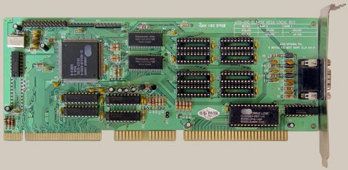

* **COOLING SYSTEM**

Cooling may be required for CPU, Video Card, Mother Board, Hard Drive, etc. Without proper cooling, the computer hardware may suffers from overheating. This overheating causes slow downs, system error messages, and crashing. Also, the life expectancy of the PC's components is likely to diminish. The following are commonly used techniques for cooling the PC or Server components:

* + Heat Sinks
  + CPU/Case Fans
  + Thermal Compound
  + Liquid Cooling Systems

**Heat Sinks:** The purpose of a heatsink is to conduct the heat away from the processor or any other component (such as chipset) to which it is attached. Thermal transfer takes place at the surface of a heatsink. Therefore, heat sinks should have a large surface area. A commonly used technique to increase the surface area is by using fins.

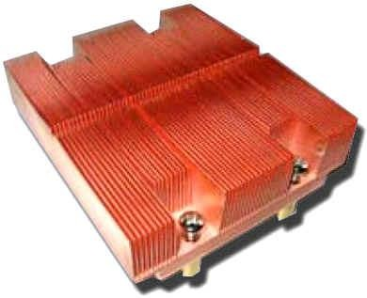

Intel Dual Core Xeon LGA 771 heatsink

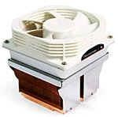**Fan:** The Fan is primarily used to force cooler air in to the system or remove hot air out of the system. A fan keeps the surrounding cooler by displacing air around the heatsink and other parts of the computer.

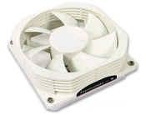

CPU Fan Heatsink with fan